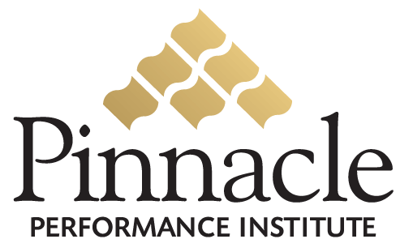

“The Pinnacle Performance Enhancement Solution allows us to deliver custom training with pinpoint accuracy in addition to the extensive catalog of Pinnacle courses.”
Kenda-Le Pernin
IBI Global
Texas State Director


Company Branded Solution: Customized with your company name, graphics, logo, colors and certificates.
Company Specific Pages: Customized with your company pages editable by you at any time with no technical skills.
Company Specific Courses: Customized company courses for your internal training needs editable by you at any time with no technical skills.
Department Specific Training: Recommended and required courses for your different team member departments.

“We can now overcome one of the major challenges we face with building our sales force; by providing the necessary training and support for them to confidently succeed.”
David Manning
Traverus
President

Performance

Enhancement

Solution

“Pinnacle addresses “warm chair attrition”, one of the biggest problems for businesses today. Unproductive employees significantly damage the efficiency of an organization.”
Scott Degraffenreid
Social Network Analyst
www.necessarymeasures.com

Pinnacle
affordable solution

No Setup Fees: There are no upfront setup or maintenance fees.
No Long-Term Contract: There is no obligation to continue if you do not receive value from the Pinnacle Solution.
No Technology: Pinnacle manages the technology behind the scenes for you, so that you can focus on your business.
No Hidden Charges – One Simple Fee: All services are included for a small monthly investment per user.

Close the Gap

between

Vision & Execution

Expose Reality…

And Act Upon It
Pinnacle
customizable solution


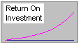
What’s It Worth?
Would you invest 2% in your team for a 20% - 50% return
in productivity and customer satisfaction?


Did You Know…

Only 48% of workers say their organization has a clear strategic direction and only 37% understand the reason for the strategic direction.
Only 44% of workers say their organization has clearly communicated its most important goals.
Only 54% of workers say they clearly understand what they are supposed to do to help their organization’s goals.
Only 15% of workers could actually identify their organization’s top three goals.
According to studies by FranklinCovey in March 2004 of 12,182 workers and another of 26,500 workers.
Online Performance
Management Solution

Execution
is exposing reality…
and acting upon it.

Measure
Strengths and Weaknesses

Build

Confidence & Competence

Collaboration
Team Involvement

Accountability

Execution Culture

clearly convey
your leadership vision,
the team experience, and
the customer relationship

Chinese Proverb:
Tell me and I will forget;
Show me and I may remember;
Involve me and I understand.

You Retain
10% of what you hear
25% of what you see
90% of what you do

Pinnacle
collaboration

Multimedia Communication: Produce near real-time communication including; new product rollouts, conventions, company announcements, , management messages, recognition, etc.
Communication Forums: You and your team members can communicate with each other on online conference rooms and discussion boards.
Team Communication: Team members can submit ideas to you in electronic 2-way suggestion boxes and dynamic surveys.

Pinnacle
confidence & Competence
Pinnacle
Performance METRICs

Company-Specific Learning: Your team members will learn from custom courses on your products, sales techniques, policies and procedures, etc.
Pinnacle Course Catalog: Your team members will learn from hundreds of public courses by trainers nation-wide.
Specific Training Groups: You can define recommended and required custom and public courses for your different team member departments and projects.
Certification Testing: You can define custom tests for team member certification and recognition.

Business Assessments: How well is your organization defining, communicating and accomplishing its objectives?
Professional Assessments: How well equipped is your team with the hard and soft skills to excel at their jobs?
Personal Performance Prescriptions: What are the specific training needs of each individual on your team?
Dynamic Surveys: Are you getting direct feedback from all members of your team and your customers?
Pinnacle
ACCOUNTABILITY

Goal Setting: Set and track company, department and individual goals.
Execution Culture: Establish a corporate culture of performance and execution.
Management Reports: Analyze important performance accomplishments through powerful management reports for effective employee reviews.

